Software Architecture and Design Specification (SAD)
Project: Chat Application (Socket Programming)
Version: 1.0
Authors: Team 5 - Omkar, Prachi Jalan, Pruthviraj Ajay Patil, Raksha Arun
Date: 04-10-2026
Status: Draft for Part-1 submission

Revision History
Version | Date | Author | Change Summary
1.0 | 04-10-2026 | Team 5 | First complete architecture and design specification, traceable to SRS v1.1

Approvals
Role | Name | Signature/Date
Team Lead / Architect | Omkar
Reviewer | Prachi Jalan
Reviewer | Pruthviraj Ajay Patil
Reviewer | Raksha Arun
Faculty | Course instructor

1. Introduction
1.1 Purpose. This document specifies the architecture and design of the Chat Application (Socket Programming), a real-time web messaging system. It realises the requirements in SRS v1.1 and is the basis for implementation and for the Test Plan.
1.2 Scope. Covers user registration and authentication, profile and contacts, one-to-one messaging, presence and typing, group chat, delivery/read receipts, chat history and search, file sharing, and unread notifications (SRS features 5.1 to 5.9). Native mobile clients, voice/video and end-to-end encryption are out of scope.
1.3 Audience. Developers, testers (QA), security reviewers, the course instructor and future maintainers.
1.4 Definitions. JWT (JSON Web Token), WSS (WebSocket over TLS), STRIDE (Spoofing, Tampering, Repudiation, Information disclosure, Denial of service, Elevation of privilege), ADR (Architecture Decision Record), DD (Design unit), REST, ODM (object-document mapper, Mongoose), RBAC.

2. Document Overview
2.1 How to use this document. Section 3 gives the architecture (components, pattern, technology, risks, traceability, security). Section 4 gives the detailed design (design units, sequence diagrams, API, error handling, UX). Requirement-to-component mapping is in 3.8 and in SRS Appendix C.
2.2 Related Documents. SRS v1.1 (Chat Application), Software Test Plan (STP) v1.0, Requirement Traceability Matrix (SRS Appendix C), Project Proposal.

3. Architecture

3.1 Goals & Constraints
- Goals: real-time delivery (95th percentile latency <= 500 ms, NFR-PERF-1); no loss of acknowledged messages (NFR-QA-2); secure by design (SO-1 to SO-5); modular code that four developers can build in parallel (NFR-QA-4); 99% availability during demonstrations (NFR-QA-3).
- Constraints: JavaScript / Node.js with WebSockets as mandated by the problem statement; MongoDB; open-source components only; student hardware (single server instance, up to 200 concurrent connections); delivery in the semester timeline.

3.2 Stakeholders & Concerns
Stakeholder | Concerns
End users (students, staff) | Instant delivery, ease of use, privacy of conversations, reliable history
Group admins | Control over membership, clear roles
Developers (team) | Modularity, clear ownership, testability, simple local setup
QA / Testers | Observable interfaces, deterministic behaviour, test data seeding
Security reviewers / instructor | Authentication, authorisation, input validation, traceability, documentation quality
System administrator | Easy deployment, logging, monitoring, backup

3.3 Component (UML) Diagram
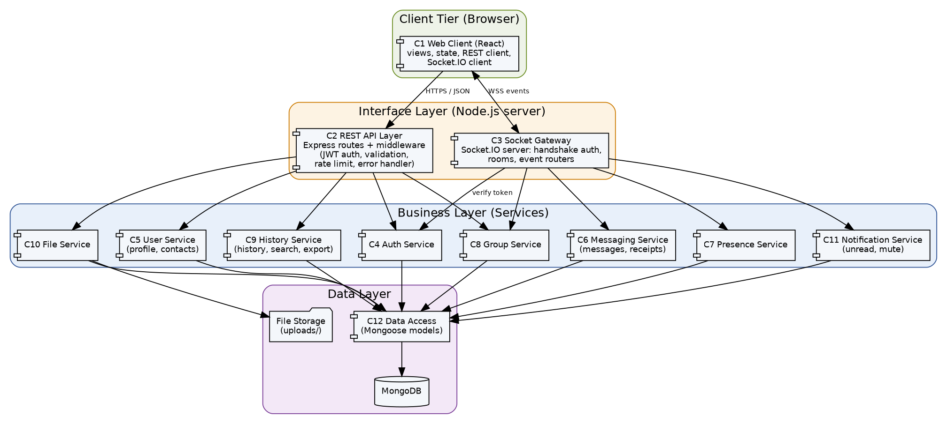
Figure 3.1: UML component diagram of the Chat Application

3.4 Component Descriptions
ID | Component | Responsibility | Provided interfaces / depends on
C1 | Web Client (React) | Screens (login, dashboard, chat, group info, profile, search); state management; REST client; Socket.IO client with auto-reconnect and resend queue; output escaping. | Uses C2 (HTTPS) and C3 (WSS)
C2 | REST API Layer (Express) | Routes for auth, users, groups, history, files; middleware chain: CORS, rate limit, JWT auth, validation/sanitisation, membership check, central error handler. | Calls C4, C5, C8, C9, C10
C3 | Socket Gateway (Socket.IO) | Authenticates the handshake, maintains the user-to-socket map, joins rooms (user:<id>, conv:<id>), routes events to services, enforces per-user rate limit and acks. | Calls C4 (verify), C6, C7, C8, C11
C4 | Auth Service | Registration, login, bcrypt hashing, lock-out counter, JWT issue and verify, password change. | C12
C5 | User Service | Profile (display name, status, avatar), user search, contact list, account deletion. | C12
C6 | Messaging Service | Validates and persists messages, de-duplicates on clientMsgId, orders by server timestamp, offline queue, delete-own-message, delivery/read status transitions. | C12
C7 | Presence Service | Online/offline state (multi-session count), last seen, typing relay to conversation room. | C12
C8 | Group Service | Create group, add/remove/rename/promote, leave, admin succession, system messages, membership checks. | C12
C9 | History Service | Conversation list, paged history (50 per page), keyword search restricted to member conversations, CSV export. | C12
C10 | File Service | Upload validation (size, extension, MIME), random file names, authorised download, attachment metadata. | C12, File Storage
C11 | Notification Service | Unread counters, mute flags, in-app notification events. | C12
C12 | Data Access (Mongoose) | Schemas, indexes, queries (parameterised) for users, contacts, conversations, members, messages, attachments. | MongoDB
- | MongoDB / File Storage | Persistent data store; uploads/ directory outside the web root. | -

3.5 Chosen Architecture Pattern and Rationale
Pattern: client-server with a layered server architecture (interface layer, business/service layer, data layer) combined with an event-driven publish/subscribe style for real-time communication (Socket.IO rooms act as topics).
- Layering separates concerns, allows each team member to own a service independently and makes services unit-testable without the network.
- Event-driven rooms give low-latency fan-out for one-to-one and group chat without polling.
- Microservices were rejected: the load (<= 200 users), team size (4) and timeline do not justify the operational complexity; the service layer is kept stateless so it could be split later.
- Peer-to-peer (WebRTC) was rejected because history, offline delivery and access control need a central server.
Architecture decisions (ADR summary):
ADR | Decision | Alternatives considered | Reason
ADR-1 | Socket.IO over WebSocket transport | Raw ws library | Built-in rooms, acks, auto-reconnect and fallback reduce effort and defects
ADR-2 | MongoDB with Mongoose | MySQL / PostgreSQL | Flexible message documents, easy text index for search, matches MERN-style stack
ADR-3 | Stateless JWT (24 h) for REST and socket handshake | Server-side sessions | Same credential for both channels; no session store needed
ADR-4 | Modular monolith | Microservices | Right size for scale and team; simpler deployment and debugging
ADR-5 | Files on local disk behind authenticated route | Cloud object storage | No external dependency; storage interface isolated in C10 so it can be swapped

3.6 Technology Stack & Data Stores
Layer | Technology
Client | React 18, Socket.IO client, Axios, plain CSS / Tailwind
Server | Node.js 18 LTS, Express 4, Socket.IO 4, jsonwebtoken, bcrypt, Multer, express-validator, express-rate-limit, helmet, pino (logging)
Data stores | MongoDB 6 (users, contacts, conversations, members, messages, attachments); local file storage for uploads
Transport | HTTPS (REST/JSON) and WSS (events/JSON), TLS 1.2+
Testing / tooling | Jest, Supertest, socket.io-client, Playwright, Artillery, OWASP ZAP, ESLint, Git/GitHub, Postman

Key indexes: messages(conversationId, sentAt), messages text index on content, users(username unique), users(email unique), members(userId, conversationId), contacts(userId, contactUserId unique).

3.7 Risks & Mitigations
Risk | Mitigation
Real-time latency degrades under load (NFR-PERF-1) | Index tuning, lean payloads, early load test with Artillery in Sprint 2
Network drops cause lost or duplicate messages | Ack + clientMsgId de-duplication + client resend queue (REQ-MSG-7)
Security flaws (XSS, injection, broken access control) | Central validation/sanitisation middleware, membership checks, ZAP scans, code review checklist
Server restart loses in-memory socket map | Clients auto-reconnect and re-join rooms; state rebuilt from the database
Single server is a single point of failure | Accepted for scope; daily mongodump backup; design keeps handlers stateless to allow Redis adapter later
Team members' modules fail to integrate | Agreed event/API contracts in 4.3, CI running unit tests on every pull request

3.8 Traceability to Requirements
SRS requirements | Component(s) | Design unit / section
REQ-AUTH-1 to 7 | C4 Auth Service, C2, C3 (handshake) | DD-AUTH; 4.2.1; 4.3.1
REQ-PRO-1 to 5 | C5 User Service, C2 | DD-PRO; 4.3.2
REQ-MSG-1 to 8 | C3 Socket Gateway, C6 Messaging Service | DD-MSG; 4.2.2; 4.3.6
REQ-PRS-1 to 4 | C3, C7 Presence Service | DD-PRS; 4.3.6
REQ-GRP-1 to 6 | C8 Group Service, C3 | DD-GRP; 4.3.3; 4.3.6
REQ-RCP-1 to 5 | C3, C6 Messaging Service | DD-RCP; 4.2.2; 4.3.6
REQ-HIS-1 to 5 | C9 History Service | DD-HIS; 4.3.4
REQ-FIL-1 to 5 | C10 File Service | DD-FIL; 4.2.3; 4.3.5
REQ-NOT-1 to 4 | C11 Notification Service, C3 | DD-NOT; 4.3.4
NFR-PERF-1 to 5 | C3, C9, C12 (indexes), C1 | DD-PERF; 3.5, 3.6
NFR-SAFE-1 to 4 | C12, C2 error handler, C10 | DD-SAFE; 4.4
NFR-SEC-1 to 7 / SO-1 to 5 | C2 middleware, C3, C4, C5, C10 | DD-SEC; 3.9
NFR-QA-1 to 7 | All components; C1 for usability | 4.5, 4.4, 3.5

The full requirement-by-requirement matrix, including code files and test cases, is SRS Appendix C.

3.9 Security Architecture
Trust boundaries: (1) Browser to server over the internet (untrusted); (2) server to MongoDB / file storage (trusted internal network, credentials in environment variables). All input crossing boundary 1 is untrusted and validated.
Threat modelling (STRIDE):
Threat | Example in this system | Control | Req.
Spoofing | Attacker logs in as another user or opens a socket with a stolen/forged token | bcrypt-hashed passwords; JWT signed with secret from environment, 24 h expiry; handshake verification; lock-out after 5 failures | NFR-SEC-1, NFR-SEC-2, REQ-AUTH-5, REQ-AUTH-7
Tampering | Modify a message or request payload; inject script / NoSQL operators | TLS; server-side validation; Mongoose parameterised queries; output escaping; senders may only delete their own messages | NFR-SEC-3, NFR-SEC-5, NFR-SAFE-2, BR-4
Repudiation | User denies sending a message | Server-assigned sender id and timestamp stored with every message; deleted messages keep audit record; auth events logged | REQ-MSG-3, BR-4
Information disclosure | Reading another conversation, history, or attachment; leaking passwords in logs | Membership check on every REST and socket operation; authenticated file download; no secrets or message bodies in logs; generic login errors | NFR-SEC-4, REQ-FIL-4, REQ-HIS-4
Denial of service | Message flooding, brute-force login, oversized uploads | Rate limits (20 msgs/10 s per user; 100 requests/min per IP); 10 MB upload cap; 2000-char messages; heartbeat timeouts | NFR-SEC-6, REQ-FIL-1, REQ-MSG-4
Elevation of privilege | Member performs admin actions; user reaches another user's data | Role check (admin/member) in Group Service; ownership checks; least-privilege DB user | REQ-GRP-2, BR-3

- Authentication flow: login returns JWT; REST calls send Authorization: Bearer; the socket handshake sends the token in auth; the gateway rejects invalid tokens before any event is processed.
- Authorisation: a membership middleware/guard is applied to every conversation, history, search, file and socket-room operation (deny by default).
- Data protection: passwords hashed (bcrypt cost >= 10); secrets in .env (not in Git, scanned with gitleaks); TLS in deployment; uploaded files stored outside the web root under random names.
- Secure configuration: helmet security headers, restricted CORS origin, dependency checks with npm audit.

4. Design

4.1 Design Overview
The server is organised in layers: routes/socket handlers (interface) call services (business logic), which use Mongoose models (data). Handlers contain no business logic, so services can be unit-tested directly. Each design unit (DD) below is owned by one team member.
Design unit | Contents | Owner | Source location (planned)
DD-AUTH | Auth routes, authService, auth middleware, User model | Prachi Jalan | server/routes/auth.js, services/authService.js
DD-PRO | User routes, userService, Contact model | Prachi Jalan | server/routes/users.js
DD-MSG | messageHandler, messageService, Message model | Omkar | server/sockets/messageHandler.js
DD-RCP | receiptHandler, status transition rules | Omkar | server/sockets/receiptHandler.js
DD-PRS | presenceHandler, presenceService | Pruthviraj | server/sockets/presenceHandler.js
DD-GRP | Group routes, groupHandler, groupService, Conversation/Member models | Pruthviraj | server/routes/groups.js, sockets/groupHandler.js
DD-HIS | History routes, historyService, text index, CSV export | Raksha | server/routes/history.js
DD-FIL | File routes, Multer config, fileService, Attachment model | Raksha | server/routes/files.js
DD-NOT | Notification service, unread counters, mute flag | Raksha | server/routes/notifications.js
DD-PERF / DD-SAFE / DD-SEC | Indexes and load design; error and backup design; security middleware (auth, validate, sanitize, rateLimit, membership) | All (Omkar, Raksha, Prachi / Pruthviraj) | server/middleware/, server/config/

Data model: see SRS Figure 3 (ER diagram) and Appendix B. Message status values are sent, delivered, read and deleted; status only moves forward.

4.2 UML Sequence Diagrams

4.2.1 Login and WebSocket connection (REQ-AUTH-3 to 7, REQ-PRS-1)
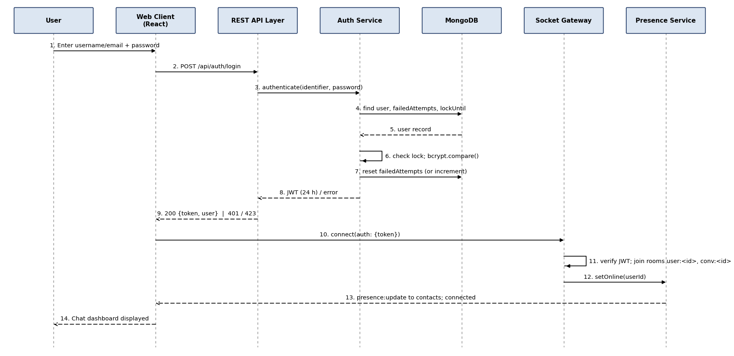
Figure 4.1: Sequence diagram - user login and socket connection

4.2.2 Send one-to-one message with delivery and read receipts (REQ-MSG-1 to 7, REQ-RCP-1 to 4)
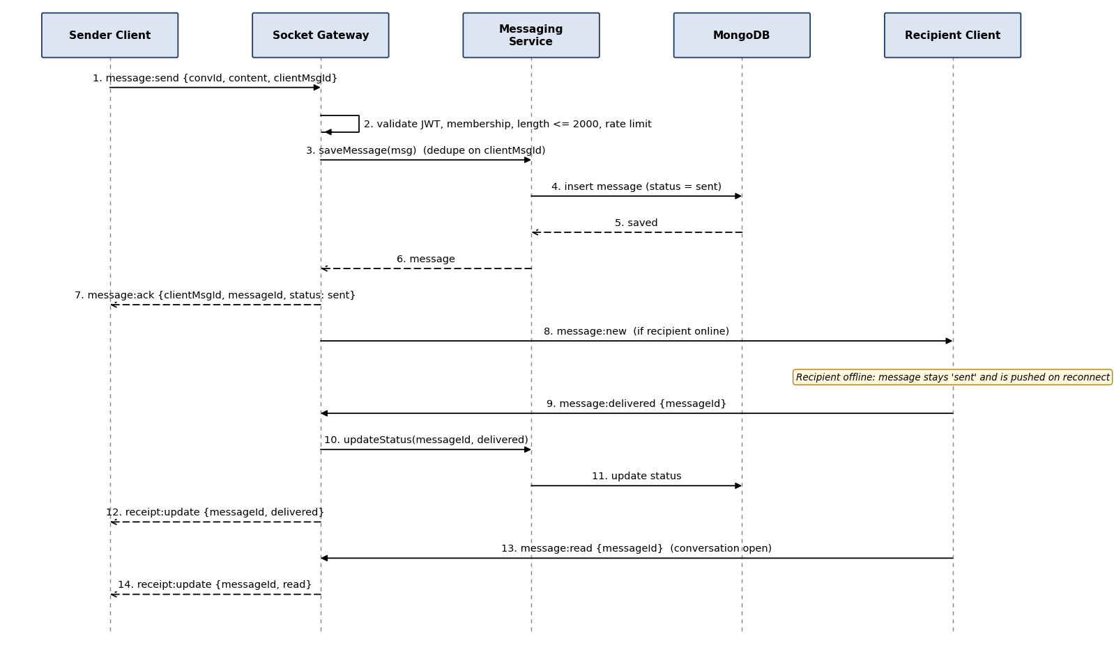
Figure 4.2: Sequence diagram - sending a message and receipt updates

4.2.3 Upload a file and share it in a group (REQ-FIL-1 to 5, REQ-GRP-3)
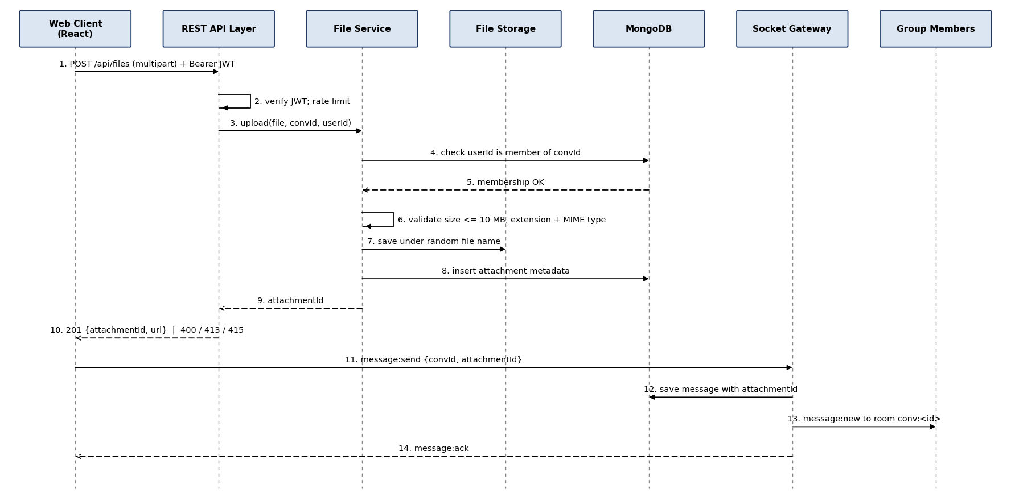
Figure 4.3: Sequence diagram - file upload and group delivery

4.3 API Design
All REST endpoints are under /api, use JSON (UTF-8), require header Authorization: Bearer <JWT> except register and login, and return errors in the standard format of 4.4. Interfaces are defined for the Auth, User, Group, History/Notification and File components and for the Socket Gateway.

4.3.1 Auth component (C4)
Endpoint | Method | Request | Response (success) | Errors
/api/auth/register | POST | {username, email, password} | 201 {userId, username} | 400 validation; 409 duplicate username/email
/api/auth/login | POST | {identifier, password} | 200 {token, expiresIn, user} | 401 invalid credentials; 423 account locked (15 min)
/api/auth/logout | POST | - | 204 | 401 invalid token
/api/auth/password | PUT | {currentPassword, newPassword} | 204 | 400 weak password; 403 wrong current password

4.3.2 User component (C5)
Endpoint | Method | Request | Response (success) | Errors
/api/users/me | GET / PUT | PUT: {displayName, statusMessage} | 200 {profile} | 400 validation
/api/users/me/avatar | POST | multipart image (JPG/PNG <= 2 MB) | 200 {avatarUrl} | 413 too large; 415 unsupported type
/api/users/search?q= | GET | query q (>= 2 chars) | 200 [{userId, username, displayName}] | 400 query too short
/api/contacts | GET / POST | POST: {contactUserId} | 200 list / 201 {contact} | 400 self-add; 404 user not found; 409 already contact
/api/contacts/:id | DELETE | - | 204 | 404 not a contact

4.3.3 Group component (C8)
Endpoint | Method | Request | Response (success) | Errors
/api/groups | POST | {name, memberIds[]} | 201 {groupId, members} | 400 name/members invalid or > 100; 404 member not a contact
/api/groups/:id/members | POST / DELETE | {userId} | 200 {members} | 403 not admin; 404 group/user not found
/api/groups/:id | PUT | {name} | 200 {group} | 403 not admin
/api/groups/:id/admins | POST | {userId} | 200 {members} | 403 not admin
/api/groups/:id/leave | POST | - | 204 (admin succession applied) | 403 not a member

4.3.4 History and Notification components (C9, C11)
Endpoint | Method | Request | Response (success) | Errors
/api/conversations | GET | - | 200 [{id, name, lastMessage, unread}] | 401
/api/conversations/:id/messages?before=&limit=50 | GET | cursor `before` (message id) | 200 {messages[], hasMore} | 403 not a member; 404
/api/search?q=&conversationId= | GET | keyword (>= 2 chars), optional conversation | 200 [{message, snippet}] | 400 query too short; 403
/api/conversations/:id/export | GET | - | 200 text/csv | 403; 404
/api/conversations/:id/mute | PUT | {muted: boolean} | 204 | 403; 404

4.3.5 File component (C10)
Endpoint | Method | Request | Response (success) | Errors
/api/files | POST | multipart: file, conversationId | 201 {attachmentId, fileName, size, url} | 400 missing; 403 not a member; 413 > 10 MB; 415 type not allowed
/api/files/:attachmentId | GET | - | 200 file stream (Content-Disposition, safe MIME) | 401; 403 not a member; 404

4.3.6 Socket Gateway events (C3) - Socket.IO over WSS
Event | Direction | Payload | Acknowledgement / error
message:send | Client to server | {conversationId, content, clientMsgId, attachmentId?} | message:ack {clientMsgId, messageId, status} or error:event {code, message}
message:new | Server to client | {messageId, conversationId, senderId, content, attachment?, sentAt} | client replies message:delivered
message:delivered / message:read | Client to server | {messageId} | server emits receipt:update {messageId, status, userId} to sender
message:delete | Client to server | {messageId} | message:deleted to room; error 403 if not sender
typing:start / typing:stop | Client to server; relayed | {conversationId} | relay typing:update {conversationId, userId, typing}
presence:update | Server to client | {userId, status, lastSeen} | -
group:update | Server to client | {groupId, type, members} | -
notification:unread | Server to client | {conversationId, unread} | -

4.4 Error Handling, Logging & Monitoring
Standard error format for REST and socket errors:
{ "error": { "code": "VALIDATION_ERROR", "message": "Password must contain a letter and a digit", "field": "password", "requestId": "b1f4..." } }
HTTP / event code | Error code | When used
400 | VALIDATION_ERROR | Missing or malformed input, rule violation (length, format)
401 | UNAUTHENTICATED / INVALID_CREDENTIALS | Missing, expired or tampered token; wrong login (generic message)
403 | FORBIDDEN | Not a member, not an admin, not the sender
404 | NOT_FOUND | Resource does not exist or is not visible to the caller
409 | CONFLICT | Duplicate username, email or contact
413 / 415 | FILE_TOO_LARGE / UNSUPPORTED_TYPE | Upload limits (REQ-FIL-1, 2)
423 | ACCOUNT_LOCKED | Too many failed logins (REQ-AUTH-5)
429 | RATE_LIMITED | Rate limit exceeded (NFR-SEC-6)
500 | INTERNAL_ERROR | Unexpected failure; details logged, generic message returned

- Central Express error-handling middleware converts every thrown error into the standard format; socket handlers are wrapped so an exception emits error:event and never crashes the process (NFR-SAFE-4). unhandledRejection / uncaughtException handlers log and keep the server running where safe.
- Client behaviour: shows the message beside the field or in a dismissible banner; on socket disconnect shows 'Reconnecting...' and queues unsent messages (REQ-MSG-7).
- Logging (pino, JSON): timestamp, level, requestId, userId, route/event, status, latency. Never log passwords, tokens, or message bodies. Security events (failed logins, lock-outs, 403s, rate-limit hits) are logged at warn level.
- Monitoring: message delivery latency (p95), active socket connections, error rate per route, failed login count, database availability. Exposed through a /health endpoint and log review; metrics are used in TC-PERF-01.

4.5 UX Design
- Layout: two-pane dashboard (conversation list and chat pane), collapsing to a single pane below 768 px for phones; minimum supported width 360 px.
- Feedback: tick icons for sent/delivered/read, typing indicator, presence dot, unread badge, upload progress bar, 'Reconnecting...' banner.
- Accessibility: 14 px minimum text, WCAG AA colour contrast, full keyboard use (Enter send, Shift+Enter new line, Esc close dialogs), labelled form fields and alt text.
- Consistency: errors in red beside the field; confirmation dialog before leaving a group or deleting a message.
- Usability target: new user sends first message within 3 minutes (NFR-QA-1), verified by TC-USAB-01.

4.6 Open Issues & Next Steps
- Decide final UI library (plain CSS or Tailwind) in Sprint 1.
- Confirm local vs. Atlas MongoDB for the demonstration environment.
- Future enhancements: end-to-end encryption, Redis adapter for multiple server instances, push notifications, voice/video, message reactions and replies.
- Next steps: Sprint 1 - project skeleton, schemas, auth and profile; Sprint 2 - messaging, presence, groups; Sprint 3 - receipts, history/search, files, notifications; Sprint 4 - hardening, performance and security testing.

5. Appendices
5.1 Glossary: JWT, WSS, STRIDE, ADR, DD, REST, ODM, RBAC, TLS (see Section 1.4 and SRS Appendix A).
5.2 References: IEEE 42010 (architecture description); IEEE 830 / SRS v1.1; OWASP ASVS and Top 10; RFC 6455 (WebSocket); Socket.IO v4 documentation; MongoDB manual; NIST SP 800-160.
5.3 Tools: Graphviz (component diagram), Python/Matplotlib (sequence diagrams), draw.io / PlantUML (editable sources if required), Postman / Swagger (API documentation), Git/GitHub.

